Price-list for additional equipment
For MEDVIN : World of liquefied and compressed gases
May 14-15, 2020
Prices are given in Euro
№ | Name | Price
 | Carpet | 7 Euro per 1 sq.m
 | Full-colour oracal panels | 15 Euro per 1 sq.m
 | One-colour oracal panels ORACAL (019-613) | 12 Euro per 1 sq.m
 | Standard inscription sign-board | 12 Euro
 | Sign-board with company logo | 17 Euro
 | Glass-windows 0,5х1 Н=2,5 | 50 Euro
 | Glass-windows 0,5х0,5 Н=2,5 | 45 Euro
 | Glass-windows radius R 0,5хR 1 Н=2,5 | 75 Euro
 | Glass-windows 0,5х1 Н=1 | 35 Euro
 | Glass-windows 0,5х0,5 Н=1 | 25 Euro
 | Glass-windows radius R 0,5хR 1 Н=1 | 45 Euro
 | Doors | 22 Euro
 | Wall panel 1х2,5 | 5 Euro
 | Wall panel 0,5х2,5 | 3,5 Euro
 | Curtain 1х2,5 | 5 Euro
 | Podium 0,5х0,5 Н=0,5/0,75/1 (reception) | 15 Euro
 | Podium 0,5х1 Н=0,5/0,75/1 | 17 Euro
 | Podium R1/R0.5 H=0,75/1 | 20 Euro
 | Shelf wood/glass 0,3 х 1 | 5 Euro
 | Rack 0,5х0,5/1 (3 shelves) | 25/40 Euro
 | Table 0,8х0,8/D 800 | 10 Euro
 | Glass table D 800 | 20 Euro | 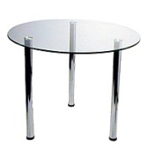
 | Chair | 5 Euro
 | Bar Chair | 15 Euro
 | Lighting for glass-windows with halogen lamps for 1 shelf | 5 Euro per 1 shelf
 | Lighting for glass-windows with diod lamps for 1 shelf | 8 Euro per 1 shelf
 | Floodlight МГ 150 Вт | 20 Euro | 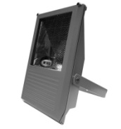
 | Floodlight | 10 Euro | 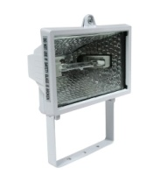
 | Luminescent lamp / spot | 6 Euro
 | Electricity connection 20 КВт | 65 Euro
 | Electricity socket 220 V | 7 Euro
 | Glass doors for glass-windows | 10 Euro
 | Upper walls | 25 Euro per 1 m
 | Rent of sound equipment | 10 Euro per 1 hour
 | Rent of TV 42 | 25 Euro per day

